



ADVANCED SPREADSHEET APPLICATIONS
(235)
STATE 2021

Production:
Job 1: Chart __________ (100 points)
Job 2: Range, Table and Sparklines __________ (90 points)
Job 3: PivotTable __________ (75 points)
TOTAL POINTS __________ (265 points)

Test Time: 90 minutes

GENERAL GUIDELINES:
Failure to adhere to any of the following rules will result in disqualification:
- Member must hand in this test booklet and all printouts if any. Failure to do so will result in disqualification.
- No equipment, supplies, or materials other than those specified for this event are allowed in the testing area. No previous BPA tests and/or sample tests (handwritten, photocopied, or keyed) are allowed in the testing area.
- Electronic devices will be monitored according to ACT standards.

INSTRUCTIONS:
- Key your Member ID and printout number in the right section of a footer on each printout on a separate line in the footer. Your name or initials should not appear on any work you submit.
- Center the following information in a header on each printout: File name and the sheet name. Each item should appear on a separate line in the header.
- If you finish before the end of the testing time, notify the proctor. Time may be a factor in determining the winner in the event of a tie.
- When turning in your contest, arrange all jobs in the correct printout order (included in instructions).
- Write your Member ID in the provided spaces on the test cover page.

`
GRADER: Points are all or none unless otherwise noted!

Job 1 (Chart) | Points Possible | Points Earned
Contestant # and Job # in right section of footer | 10
File name and sheet name in the header | 10
Merge and Center the Title over A1:E1 | 5
Bold and Center Header Row Information | 5
Create a 2-D Line Graph with Markers comparing treatment | 15
Switch Data on the X and Y axis | 10
Label the X and Y axis | 10
Chart Title | 5
Legend on the Right of the Chart | 5
Chart color is Colorful Color 4 | 5
Filter Chart to show only Control, Heat and Water Bath | 15
Data fits to one page | 5
Subtotal | 100
Job 2 (Range, Table and Sparklines) | Points Possible | Points Earned
Contestant # and Job # in right section of footer | 10
File name and sheet name in the header | 10
Format data as a Table, Table Style Medium 2 | 10
Remove table Filters | 5
Show a table Total Row | 5
Find the Average for each month | 10
SUM Formula for cells B12:B15 | 10
Column Sparkline for each employee | 10
High Point in each Sparkline | 5
Sparkline Style Accent 5, Lighter 40% | 5
Landscape Orientation and fit to page | 5
Print Data and formulas | 5
Subtotal | 90

Job 3 (Pivot Table) | Points Possible | Points Earned
Contestant # and Job # in right section of footer | 10
File name and sheet name in the header | 10
Pivot Table created correctly | 20
Filter data to show Male cats and dogs | 10
PivotChart style changed to Style 3, color changed to Colorful Color 4 | 10
Correct Title | 5
Legend removed | 5
X Axis labeled, Animal | 5
Subtotal | 75
TOTAL POINTS | 265

Job 1 – Chart

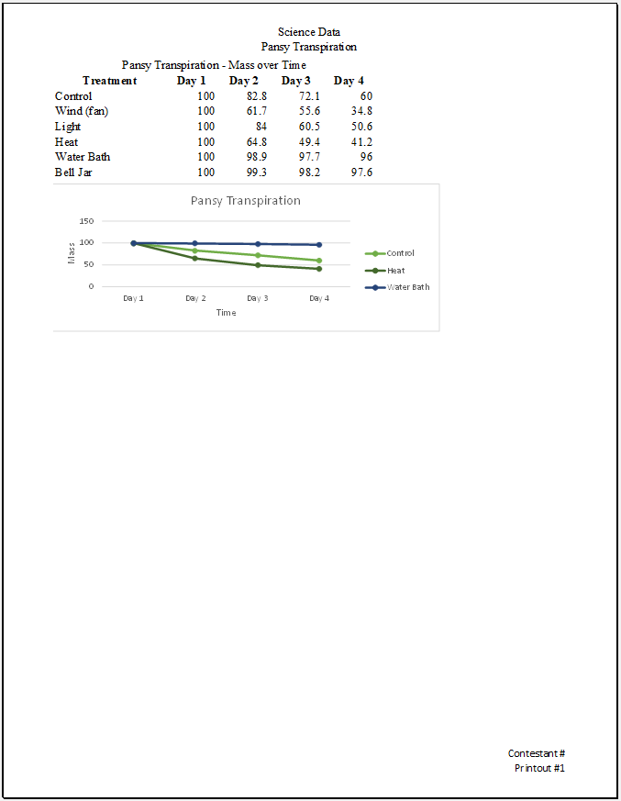

Job 2 – Range, Table and Sparklines
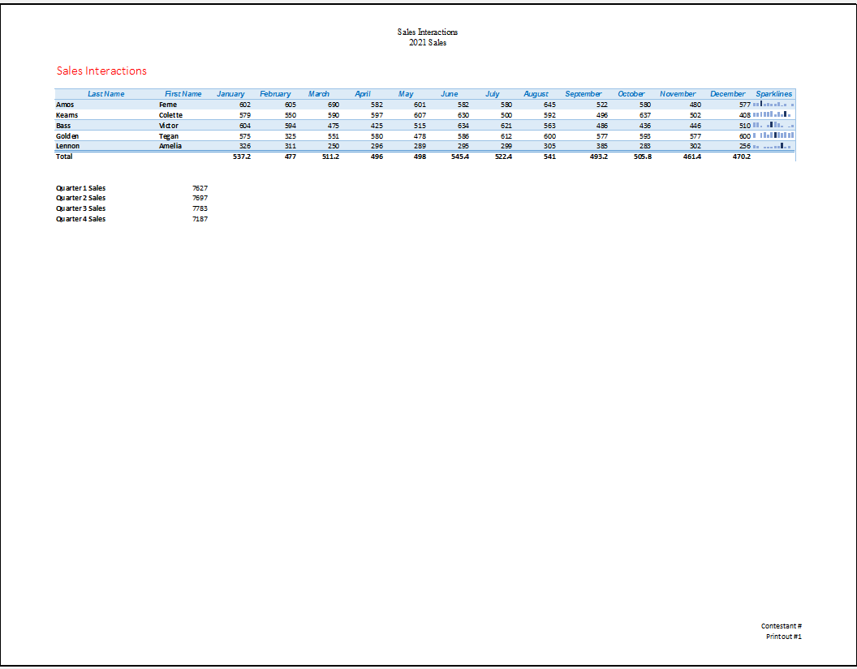
Job 2 – Range, Table and Sparklines (formulas)
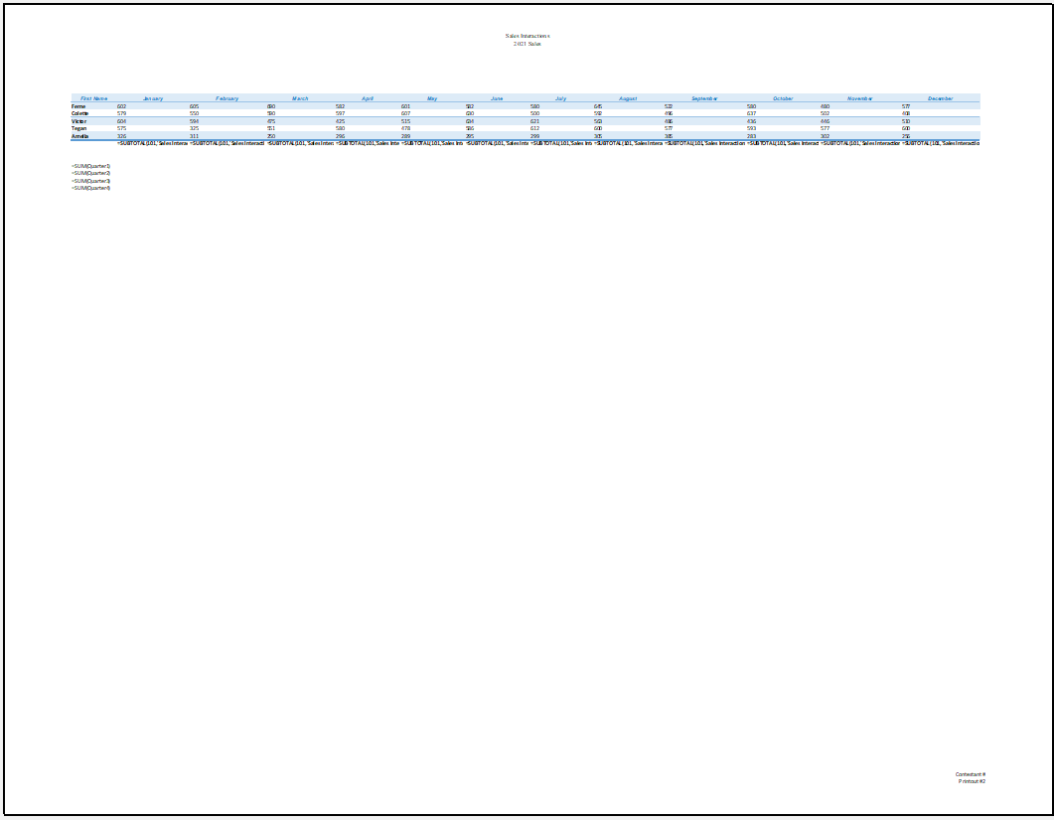
Job 3 – Pivot Table
